**1喜欢的一幅画**

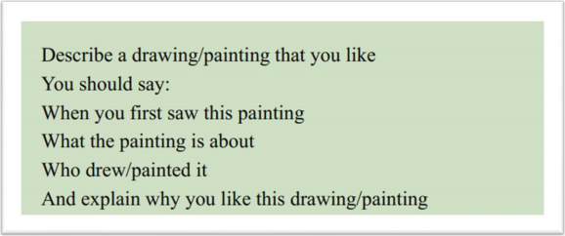

The first painting that popped into my mind is that my best friend drew it and gave it to me. There is a cake in the middle of this painting. It is brown in color and has a few cherries on it. The whole painting is a very cute cartoon style. Actually, I made the cake for her 25th birthday. It was a handmade mousse cake, my best friend’s favorite flavor! I spent the whole day making this cake, and she felt so excited, so happy, so, how to say, exhilarated to receive such a present. And my friend drew a picture of this a few days later, to commemorate the moment and give it to me in return.

And I still remember the end of that day, when I saw this painting, I thought a lot, from the birthday party, the cake to other stuff. It seems that there used to be a line, I mean, a boundary, between us, but because of the painting, the boundary was gone. We became much closer, and that’s great. Every now and then, I would watch the drawing, and feel like I am the luckiest person in the world because I have a wonderful relationship.

When you think about friendship, or any other interpersonal relationships, it is always about loving and caring for each other. I mean, no one is an island. Sending a handmade gift, like a painting, is the best way to say: we are bonding. When someone receives something so kind, so personal, so genuine, they will be touched. That’s why I like this drawing so much.

Part 3:

1. What are the differences between painting色彩 and drawing线条?

2. Why do some people keep a painting for a long time?

3. How does building style affect people’s lives?

4. Should children learn to draw and paint? Why?

5. How do young people share arts with others?

6. Do you think the objects we use in our daily lives should be beautifully designed?

**2中文很好的外国人**

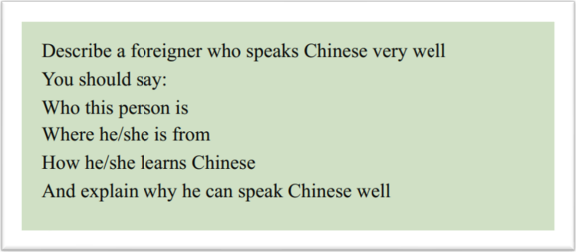

His name is S, which can be loosely translated as Mr. S. He is American, and also an influencer on Youtube. He creates videos about his Chinese studying methods and experience.

Actually, I found out about him by accident. My friend was browsing videos on Youtube the other day, and shared his videos with me. The video, I still remember, was about how to memorize difficult vocabulary in Chinese. It was so interesting, so intriguing, and it captivated me at once, and I started following him since then.

Basically, he shares videos about his Chinese studying experiences, studying methods, and even life lessons, sometimes. From his video, you can totally tell that he is so smart, it’s like everything in language studying is just a piece of cake to him, he is almost, how to put it, omniscient, I guess. The most impressive video was how he managed to remember 1000 Chinese words in three days. I mean, come on, that’s more than difficult, it’s very difficult, it’s a daunting task. But, he did it! He shared how he divided these words into different groups, and how he adopted various ways to memorize them, and even how he took advantage of different locations to consolidate the memories. I was surprised to see this, no, I was more than surprised, I was stunned.

This is him, a superman in the Chinese -studying field. I guess I followed him not only because he is a foreigner who can speak Chinese well, but also because he has all the right way of learning languages, and deep deep down, he resonates with me, I want to become smart, become brilliant, and become omniscient as well. And I believe his videos are going to go viral on B very soon.

**Part 3:**

1. What foreign languages do Chinese children learn?

2. Why do Chinese children learn English?

3. Why are so many people learning English?

4. How can you help children learn English?

5. Do you think the way people learn English today is the same as in the past?

6. What are the benefits of the Internet for people’s learning?

**3素未谋面的有趣人**

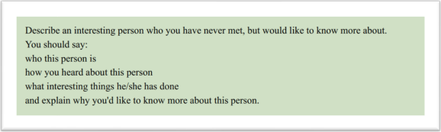

His name is S, which can be loosely translated as Mr. S. He is American, and also an influencer on Youtube. He creates interesting videos about his studying methods and experience.

Actually, I found out about him by accident. My friend was browsing videos on Youtube the other day, and shared his videos with me. The video, I still remember, was about how to improve your spoken Chinese by communicating with strangers. It was so interesting, so intriguing, and it captivated me at once, and I started following him since then.

Basically, he shares videos about his Chinese studying experiences, studying methods, and even life lessons, sometimes. From his video, you can totally tell that he is so smart, it’s like everything in language studying is just a piece of cake to him, he is almost, how to put it, omniscient, I guess. The most interesting video was about him going to any random coffee shop, finding a Chinese person and communicating with him in Chinese. I mean, come on, that’s more than difficult, it’s very difficult, it’s a daunting task. But, he did it! He shared how he chooses a coffee shop and buys a cup of coffee. Then, he carries the cup of coffee to look for someone who speaks Chinese. He asked in the crowd: I'll give you a cup of coffee, can you speak Chinese with me for 10 minutes? Finally, he found a Chinese girl and talked to her for half an hour. I was surprised to see this, no, I was more than surprised, I was stunned.

This is him, a interesting person in the Chinese -studying field. I guess I followed him not only because he is a foreigner who can speak Chinese well, but also because he is so funny, and deep deep down, he resonates with me, I want to improve my spoken English by communicating with strangers.

**Part 3:**

1. Are there any differences in the relationship between you and your friends and between you and other people?

2. Do people feel lonely in crowded cities?

3. Where and how can people get to know new people?

4. Can clothing tell and reveal a person’s personality?

5. Why do individuals from the same family have different personalities?

6. How does society influence a person’s personality?

**4喜欢做饭的人**

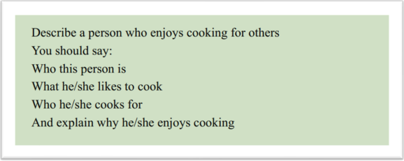

Her name is MY, which can be loosely translated as Miss MY. She is an influencer on B. She creates videos about her cooking methods and experience.

How I knew her? Actually, I found out about her by accident. My friend was browsing videos on B the other day, and shared her videos with me. The video, I still remember, was about how to use normal ingredients to recreate restaurant cuisine like Michelin starred restaurant at home. It was so interesting, so intriguing, and it captivated me at once, and I started following her since then.

Basically, she shares videos about her cooking experiences, kitchen recipes, and even life lessons, sometimes. From her video, you can totally tell that she is so energetic, it’s like she can stay in the kitchen forever, she is almost, how to put it, inexhaustible, I guess. The most impressive video was how she managed to conjure up 10 dishes in two hours. I mean, come on, that’s more than difficult, it’s very difficult, it’s a daunting task. But, she did it! She cooked up a storm! She shared how she bought different ingredients in advance, and how she decided the order of cooking different things, and even how she took advantage of different parts of vegetables to make two dishes. I was surprised to see this, no, I was more than surprised, I was stunned.

I think cooking can bring her a sense of accomplishment. When she is cooking, she does not regard it as a task, but as an artistic creation. I think that is why she enjoys cooking so much.

**Part 3:**

1. What do we need to prepare when we need to cook?

2. Do you agree that food is an important part of Chinese festivals and ceremonies?

3. Which dishes are a must at festivals?

4. Do you think cooking should be a compulsory or a selective course? Why?

5. Are there any differences between cooking today and in the past?

6. Do you agree that food is an important part of Chinese festivals and ceremonies?

**5感到幸福的照片**

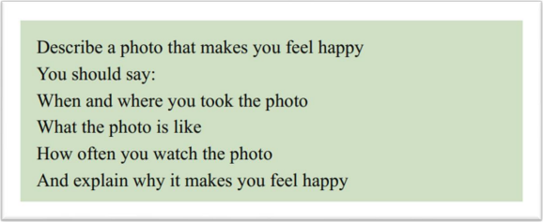

The first photo that popped into my mind was taken on my best friend’s 25th birthday. There is a cake in the middle of this painting. It is brown in color and has a few cherries on it. My friend and I sat on either side of the cake and said "yeah" to the camera. Actually, I made the cake for her 25th birthday. It was a handmade mousse cake, my best friend’s favorite flavor! I spent the whole day making this cake, and she felt so excited, so happy, so, how to say, exhilarated to receive such a present. And that is when we took this photo together, to commemorate the moment.

And I still remember the end of that day, when I saw the photo we took, I thought a lot, from the birthday party, the cake to other stuff. It seems that there used to be a line, I mean, a boundary, between us, but because of the painting, the boundary was gone. We became much closer, and that’s great. Every now and then, I would watch the photo, and feel like I am the luckiest person in the world because I have a wonderful relationship.

When you think about friendship, or any other interpersonal relationships, it is always about loving and caring for each other. I mean, no one is an island. Taking a photo to commemorate something, is the best way to say: we are bonding. When we look back to this photos, we will be touched. That’s why I like this photo so much.

**Part 3:**

1. Do you think people take more photos now than in the past?

2. Do you think equipment is important for photography?

3. Do you think being a professional photographer is a good job? Why?

4. Do you think people are taking too many photos these days?

5. What kinds of photos do people like to take?

6. Why do some people like to post their photos on social media?

**6感兴趣的科学领域**

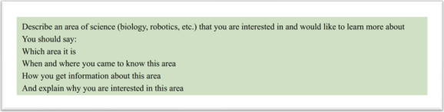

I have to say it’s the VR technology. VR is short for…virtual reality, maybe? I am really interested in this area. This information mainly exists on the Internet, so I often surf the Internet to check the latest vr technology information, watch the videos and new product launches.

I came to know this area when I bought a pair of VR glasses. With a pair of VR glasses, I can go anywhere I like. For example, I have always been very attached to loads of famous tourist attractions such as the pyramids of Egypt and the Great wall of China. I was not able to be there because of my heavy study and workload. But with a pair of vr glasses I can see these landscapes without leaving outside. It is just so peaceful and quiet, or you may say, it is tranquil.

Besides the glasses, do you know that in estate agency in China, they use vr viewing technology to allow clients to see the interior of the house they want to rent or buy without leaving their homes. With this technology, it is easy for me to feel the house type, as if I were there. Everything can be so natural, so real, and so tangible.

And more amazingly, the VR technology helps us to escape from the reality we hate. I mean, people living in the city are always so busy. They are always buzzing around, never willing to spare a second to say hi. You can feel the distance between people. But with VR technology, we can escape from the city and fly all the way to the place we like. It makes me feel relaxed, so I am interested in this area and want to explore more about this area.

**Part 3:**

1. Why do some children not like learning Science at school?

2. Is it important to study Science at school?

3. Which science subject is the most important for children to learn?

4. Should people continue to study Science after graduating from school?

5. How do you get to know about scientific news?

6. Should scientists explain the research process to the public?

**7学校/工作中的重要规定**

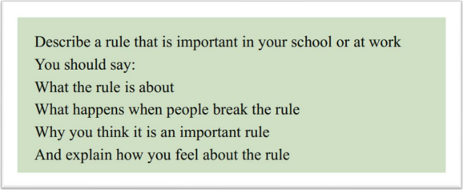

The first rule that popped into my mind is being punctual and not arriving late for class. This rule is quite straightforward, requiring students to be in the classroom on time before each lesson begins.

Back when I was in primary school, the teachers emphasized this rule right from the first day of school. And this rule has been used from primary school to university. Additionally, the school would provide students with a handbook that contained various school rules and regulations, including the one about punctuality.

If a student were to break this rule, there were usually consequences. I still remember one time in college when I was late for a class meeting and the teacher punished me by telling me to do some on-campus services. It was a hot summer day, and I swept the floor in the school building for a whole hour. After this punishment, I decided that I would never be late again.

I still remember the end of that day, my teacher talked a lot with me, from being late to other stuff. He said loads of importance of being punctual. Firstly, it teaches students the value of time management, a crucial skill for their future endeavors in work and life. The consequences for being late in a professional setting can be far more severe. Secondly, this rule helps maintain order in the classroom, ensuring that every student can benefit from a structured learning environment. After hearing what he said, I completely agreed with him. The rule against being late for class plays a vital role in school, and I consider it to be a fundamental aspect of education.

**Part 3:**

1. What rules should children follow at home in your country?

2. On what occasions can children be forgiven if they don’t follow some rules?

3. What rules should people follow when using public transport?

4. What kinds of rules do people need to follow in public places?

5. What are the reasons that cause people to break rules?

6. When people break rules, how would they be punished in your country?

**8人生转折点**

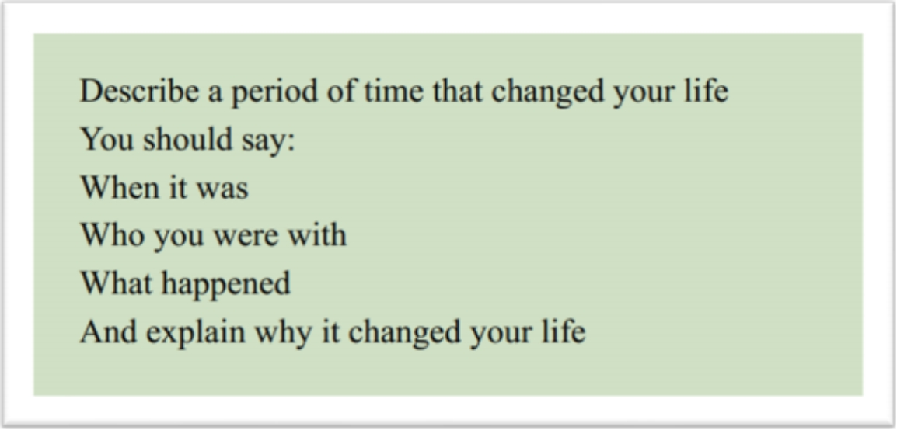

This reminds me of a period of time kinda embarrassing but the result also romantic. Once before, I had a bad quarrel with my best friend and we didn’t talk for a long time. I’ve always been someone who doesn’t admit when something is wrong and never apologises to others first. During several months, I really wanted to make up quickly, so I decided to find a good way to apologize. I think that really changed my life.

At that day, I was being mysterious all day.

And I still remember the end of that day.

When you think about friendship, or any other interpersonal relationships, it is always about loving and caring for each other. I mean, no one is an island. Making a handmade gift to apologize is the best way to say: we are bonding. With this period of time I have become more capable of dealing with issues between friends and more positive about life. I think that is why it changed my life.

**Part 3**

1. Do you like new things or changes in life?

2. Why do some people quit and change jobs?

3. How do you adapt to changes in life?

4. Who can adapt better to changes, children or adults?

5. When things like getting married or moving home happen, what kinds of things would you consider?

6. What are the disadvantages when people keep making changes?

**9累人的活动**

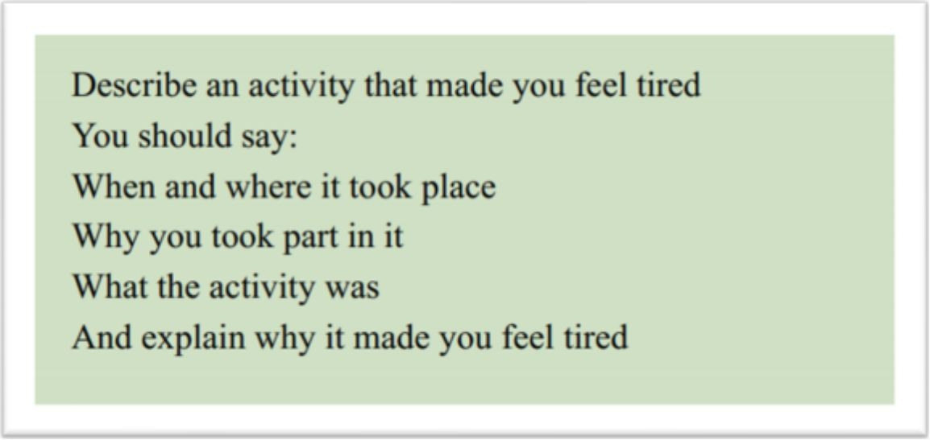

Well, the first activity that popped into my mind is boating. My friends and I went boating in a small river in the countryside just near our city.

Actually, I decide to take part in this activity by accident. My friend was browsing videos on bilibili the other day and shared this video with me. The video, I still remember, was about how to complete a one day boating in the river of countryside. It was so interesting, so intriguing, and it captivated me at once, and I started searching for the information about this spot and decided to go boating with my friends. At this moment, I don’t realise the seriousness of the problem, I mean, how tiring it is.

Basically, this activity is about boating in the river of countryside, enjoying the landscape, and making friends. It’s so difficult! Think about it! I need to control the direction of paddle, use the strength of my arms properly in order to keep my persistence, and work well with my teammates to keep our movements consistent and thus more efficient. Actually, I need to have continuous practice right? It’s so time-consuming. After a long day of boating, everyone was exhausted.

But the good thing is that we can enjoy the beauty of nature when we are boating. Everything can be so natural, so real, and so tangible.

**Part 3:**

1. Does studying and learning make people tired today?

2. When do people usually feel tired?

3. What do you think about striving for learning and striving for sports?

4. How much free time do you think office workers should have?

5. Do people have fewer holidays now than in the past?

6. What are the differences between feeling tired after studying and after exercising?

7. How can people solve the problem that old people easily get tired?

**10聚会**

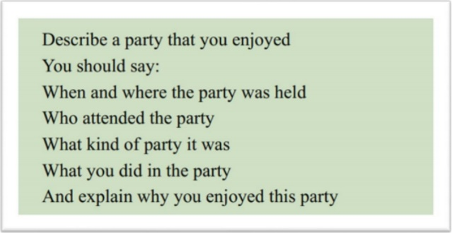

The first party that popped into my mind is my best friend’s 25th birthday party.

Several months ago, it was my best friend’s 25th birthday. I and her other friends decided to hold a party to celebrate her birthday. On that day, I was being mysterious all day. I told her I had a big surprise for her. We met at a nice little restaurant as planned. I carefully placed a beautiful cake on the table. It was a handmade mousse cake, her favorite flavor! She felt so excited, so happy, so, how to say, exhilarated to receive such a birthday present.

In this birthday party, we ate birthday cake, blew out birthday candles, made birthday wishes, ate lots of yummy food and drinks, and played table games together.

And I still remember the end of that day, we talked a lot, from the cake to other stuff, it seems that there used to be a line, I mean, a boundary, between us, but because of the cake, the boundary was gone. We became much closer, and that’s great.

When you think about friendship, or any other interpersonal relationships, it is always about loving and caring for each other. I mean, no one is an island. Sending a handmade gift is the best way to say: we are bonding. When someone receives something so kind, so personal, so genuine, they will be touched.

**Part 3:**

1. Why do people like parties?

2. Why do some people not like going to parties?

3. Do you think music and dancing are a must at a party?

4. What would you do if you were disturbed by a neighbour’s party?

5. What are the differences between holding a party at home and in a public place?

6. Do you think those who tend to stay at home are less healthy than those who often attend parties?

**11城市公园/花园**

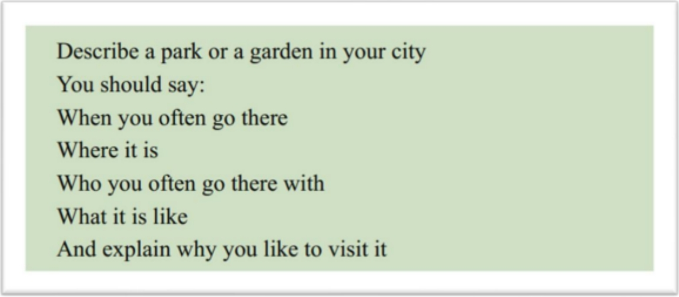

The first garden that popped into my mind is a garden called Fenghuang Garden, just near my community. It’s a beautiful garden where people can sit down and chat and where I can go running every evening.

This park is a good solution to the need for green areas for the surrounding residents. It is just so peaceful and quiet, or you may say, it is tranquil. It slows everything down, and blocks out all the hustle and bustle of the city.

I go there almost every evening by myself, running along the outer circle. It is easier for me to feel the beauty of nature when I am there. You can always find peace there. It’s not a cliché, I really feel so. I do. In the garden, you don’t need someone else to tell you spring is here. Instead, you get to see the little buds and the sprouting flowers. I mean, you can see the change of seasons, and it’s with your own eyes. Everything can be so natural, so real, and so tangible.

Another benefit of this garden is that it reinforces the bonds between people. I mean, people living in the city are always so busy. They are always buzzing around, never willing to spare a second to say hi. You can feel the distance between people. We are separated by endless traffic jams, by all the tall, fancy but boring buildings. But now, things are totally different: with the garden, people, including me, my parents, my grandparents, and all the neighbors can all sit down and chat. The community is small but close-knit now. People know each other, care about each other, and sympathize with each other. It’s good to know there is always a place like this in the big city.

**Part 3:**

1. Do young people like to go to parks?

2. What do old people like to do in parks?

3. What are the benefits of going to the park for young people and old people?

4. Why do some people like planting flowers?

5. What benefits can parks bring to a city?

6. Would you say people should help maintain public parks and gardens?

**12糟糕的服务**

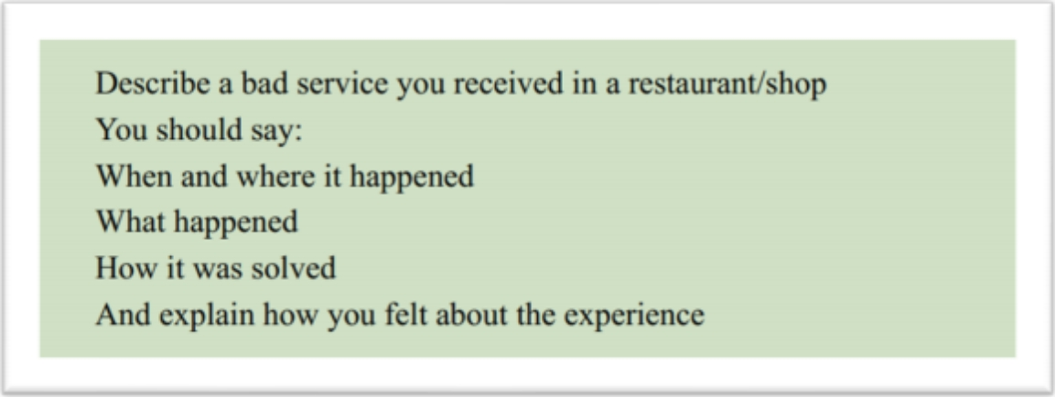

The first bad service that popped into my mind is the 25th birthday of my best friend. Something went wrong with the restaurant, and the whole event was ruined.

Several months ago, it was my best friend’s 25th birthday. We made an appointment to go to a restaurant to celebrate her birthday. On that day, I was being mysterious all day. I told her I had a big surprise for her. Actually I made a cake for her. It was a handmade mousse cake, her favorite flavor! I arrived at the restaurant early and told the waiter to put the cake in the fridgerator and give my friend a big surprise when she arrived. The waiter readily agreed.

But the problem came up. When my friend arrived, the cake didn’t come. I was in a hurry and kept pushing the waiter. And then, the waiter told me that the cake was broken by them. It’s so terrible! I just can’t believe they screwed up my birthday surprise for my friend. Eventually, the owner of the restaurant gave us another birthday cake twice as big as ours as compensation and gave us a discount.

And I still remember the end of that day, we talked a lot, from the cake to other stuff, it seems that there used to be a line, I mean, a boundary, between us, but because of the cake, the boundary was gone. We became much closer, and that’s great.

This bad service was a hiccup in my friendship with my friend. We’ll remember this birthday from time to time. When you think about friendship, or any other interpersonal relationships, it is always about loving and caring for each other. I mean, no one is an island. Sending a handmade gift is the best way to say: we are bonding. When someone receives something so kind, so personal, so genuine, they will be touched.

**Part 3:**

1. How do most people respond to bad services?

2. Do you think services are better now than in the past?

**13等待美好事物**

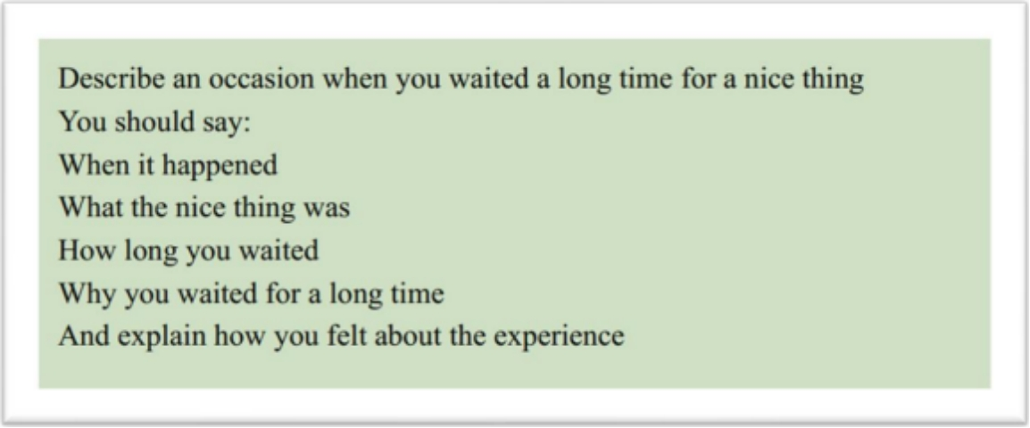

This reminds me of my best friend’s 25th birthday. A week before her birthday, I started to prepare for her big day. Actually I made a cake for her birthday. It was a handmade mousse cake, her favorite flavor! Actually, I was not professional chef. But this is a unique present. One of a kind! Think about it, I had to search for the recipe, collect all the ingredients, and all the mixing and stirring! After all, I could just buy one, right? But I did not. That made the cake so special and so precious. During the one-week waiting, I felt thrilled, and couldn’t help thinking about how she would react to my surprise. Every day when I got up, I would check the calendar and counted down the time before her birthday.

On that day, I was being mysterious all day. I told her I had a big surprise for her ahead of time. I carefully placed a beautiful cake on the table. I told her, I spent the whole week making it. She felt so excited, so happy, so, how to say, exhilarated to receive such a present.

And I still remember the end of that day, we talked a lot, from the cake to other stuff, it seems that there used to be a line, I mean, a boundary, between us, but because of the cake, the boundary was gone. We became much closer, and that’s great.

When you think about friendship, or any other interpersonal relationship, it is always about loving and caring for each other. I mean, no one is an island. Sending a handmade gift is the best way to say: we are bonding. When someone receives something so kind, so personal, so genuine, they will be touched.

**14钦佩的运动员**

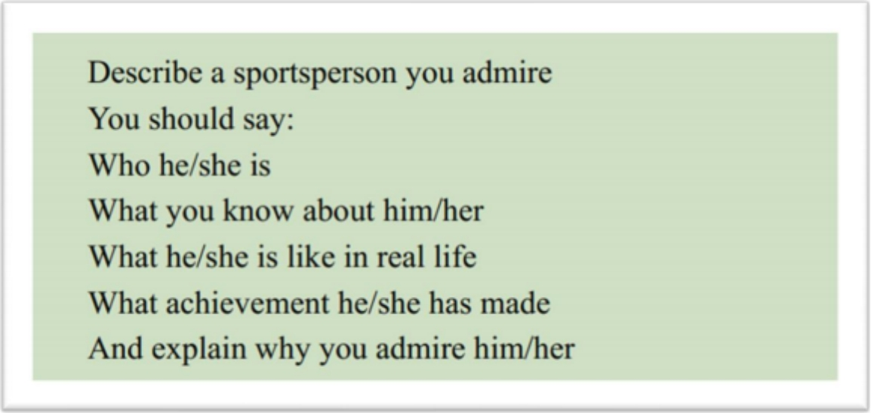

His name is SU Bingtian, which can be loosely translated as Mr. S. He is the most famous sprinter in our country after Liu Xiang.

Actually, I found out about him by accident. My dad was watching TV the other day and noticed that there was a live stream of the Tokyo Olympics events on TV. The TV footage, I still remember, was when Su set an amazing record in the 100-meter race at the Tokyo Olympics. It is the best record which has been achieved by a Chinese person, or member of the Asian race, in any international competitions.

I still remember that day when Su attended the 100-meters Olympic Games, my family and I were all cheering for him, even my old grandpa joined in. We shouted his name so loud when he started to run and became insane when he broke the record. What an impressive and memorable moment it was! Nearly all the social media were promoting Su’s achievements. Although he did not win the Olympic gold medal, he won the respect and admiration of all Chinese people and even the world.

All I know about him is what I found on internet. He is not tall, only about 1.7 meters, which means his chances are obviously much poorer than that of the other players all over the world. But Su focused on improving his skills and had been training for a decade. I mean, come on, that’s more than difficult, it’s very difficult, it’s a daunting task. But, he did it! Finally, he made great and unbelievable achievements.

This is him, a superman in track and field. I guess I admire him not only because his unbelievable achievements, but also because his extraordinary perseverance. And deep deep down, he resonates with me, I want to become a hardworking person and have an extraordinary perseverance as well.

**Part 3:**

1. Should students have physical education and do sports at school?

2. What qualities should an athlete have?

3. Is talent important in sports?

4. Is it easy to identify children’s talent?

5. What is the most popular sport in your country?

6. Why are there so few top athletes?

**15给他人建议**

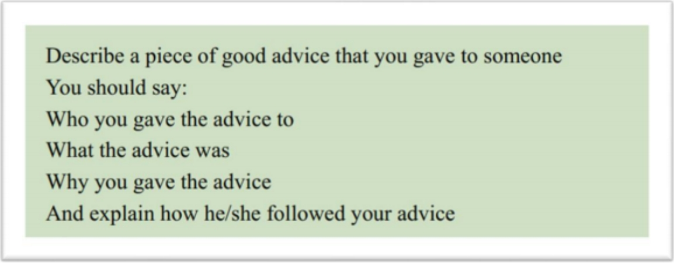

This reminds me of a piece of advice kinda embarrassing but the result also romantic. That counts as a good advice. Once before, my little sister had a bad quarrel with her best friend and they didn’t talk for a long time. My sis have always been someone who doesn’t admit when something is wrong and never apologises to others first. During several months, she really wanted to make up quickly, but she didn’t know how to do, so she decided to ask me some advice. I told her that the best way to do was to apologise directly and sincerely. And She can make some gifts for her friends with her own hands.

Because When you think about friendship, or any other interpersonal relationships, it is always about loving and caring for each other. I mean, no one is an island. Making a handmade gift to apologize is the best way to say: we are bonding. With this period of time I have become more capable of dealing with issues between friends and more positive about life.

My sister took my advice and made a cake for her friend by hand. It was a handmade mousse cake, her friend’s favorite flavor! Her friend felt so excited, so happy, so, how to say, exhilarated to receive such a present.

And I still remember the end of that day, they talked a lot, from the cake to other stuff, it seems that there used to be a line, I mean, a boundary, between them, but because of the cake, the boundary was gone. They became much closer, and that’s great.

**Part 3:**

1. Do you think parents should give their children advice?

2. Should teachers give students advice?

3. Do you think it is necessary for us to listen to friends’ advice?

4. How do people give young people and old people advice?

5. Have you ever received any advice from professional people, like a doctor, a lawyer, or a teacher?

6. Who are more willing to listen to advice? And who are less willing?

**16工作/学习的困难任务**

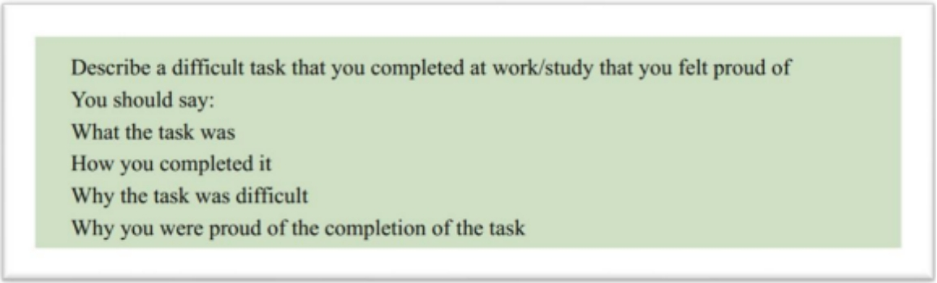

The first difficult task that popped into my mind is an English speech. In fact, I’m not very talkative, I am not a speech person and I’m shy, so speaking in front of a lot of people is difficult for me.

I was chosen by the teacher to give the speech and I was supposed to share with my classmates my studying experiences, studying methods, and even life lessons, if possible. At last I decided to share how to memorize difficult vocabulary in English. My most impressive experience was how I managed to remember 1000 words in three days. I mean, come on, that’s more than difficult, it’s very difficult, it’s a daunting task. But, I did it. I rehearsed this speech for many times but I was still nervous because I have to stand on the stage and face with the whole class about 60 peoples. I therefore shared how I divided these words into different groups, and how I adopted various ways to memorize them, and even how I took advantage of different locations to consolidate the memories.

At last, the speech received surprisingly good feedback. Someone wrote comments like: “It was so interesting, so intriguing, and it captivated me at once”, and another comment said: “I was surprised to see this, no, I was more than surprised, I was stunned.” I was truly proud of myself because I overcame myself and my fears. I accomplished what I thought was impossible.

**Part 3:**

1. What are the things that make people feel proud of?

2. Do people often feel proud of themselves when they complete a difficult task?

3. What challenges do young people face today?

4. How do young people handle difficult or challenging tasks?

5. What kinds of rewards do people receive from work?

6. What are the most difficult jobs that people do?

**17成功的经营者**

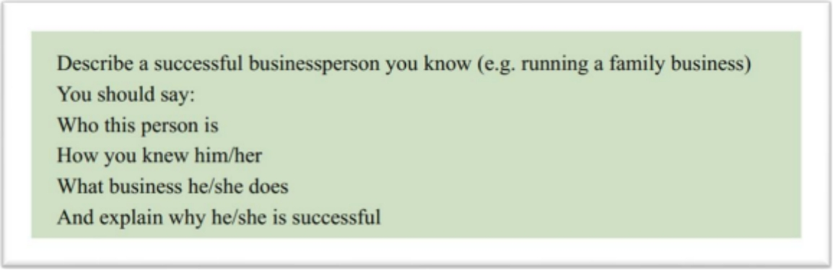

His name is S, which can be loosely translated as Mr. S. He is a coffee shop owner, and also an influencer on Bilibili. He creates interesting videos about his Coffee making process and experience.

Actually, I found out about him by accident. My friend was browsing videos on Bilibili the other day, and shared his videos with me. The video, I still remember, was about how to making ten different kinds of coffee. It was so interesting, so intriguing, and it captivated me at once, and I started following him since then.

Basically, he shares videos about his coffee making process, coffee shop management idea, and even life lessons, sometimes. From his video, you can totally tell that he is so smart, it’s like everything in the coffee business is just a piece of cake to him, he is almost, how to put it, omniscient, I guess.

What I find most impressive about him is the ability to build a successful business from scratch. Starting a chain of coffee shops, especially in a competitive market. I mean, come on, that’s more than difficult, it’s very difficult, it’s a daunting task. But, he did it! He has not only succeeded in developing coffee-making technology, but also creates videos on the Internet to increase customer flow as well as show his business acumen and dedication. His success story serves as an inspiration to aspiring entrepreneurs.

This is him, a successful person in coffee-making field. I guess I said he is successful not only because he can make coffee well, but also because he can use online media to increase revenue for his coffee shop. And deep deep down, he resonates with me, I want to become a smart businessman as well.

**Part 3:**

1. What factors lead to success?

2. What do people need to sacrifice for success?

3. Is it easy for a business to be successful without affecting the environment?

4. Which is more likely to be successful, family businesses or large corporations?

5. Can you provide some examples of family businesses in your country?

6. What qualities should be considered when recruiting employees?

**18电脑出问题**

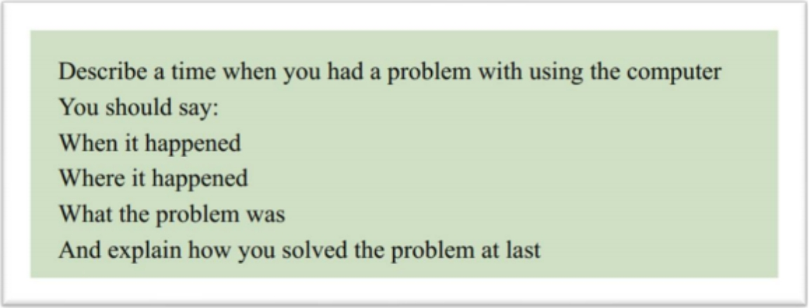

The first time that popped into my mind was when I took part in my friend’s 25th birthday party. It should be romantic and perfect, but I broke my computer.

I remember vividly that I was being mysterious all day. I told her I had a big surprise for her. We made an appointment to meet at a nice little restaurant and I arrived in advance. I carefully placed a beautiful cake on the table. It was a handmade mousse cake, my favorite flavor! And my computer was on this table too because I was working on my assignment before she showed up.

During this small birthday celebration, we ate birthday cake, blew out birthday candles, made birthday wishes, ate lots of yummy food and drinks, and played video games together. As of this moment, everything is fine. And then, something went wrong and is terrible. While we were playing table games, I got too excited and knocked over the soda and it spilled everywhere, and I watched my computer go from dead to a black screen and then never open again.

The rest of the night was all about trying to repair the computer. We searched on the phone and tried every method. We even tried to bury the computer in the rice, I mean, the rice that hasn’t been cooked. The Internet guys said it would help to suck up all the moisture.

However, at last, no luck. This taught me a lesson: no soda, don’t get excited, and buy new computers that are waterproof.

**Part 3:**

1. Why do people often have problems when using new products?

2. What do you think of people who are addicted to playing computers?

3. How do people use digital devices to help them with their studies?

4. Do people spend too much time looking at digital screens? Why?

5. Do you think that parents should limit the time that their children spend using the mobile phones?

6. What do people do with mobile phones?

**19有用的广告**

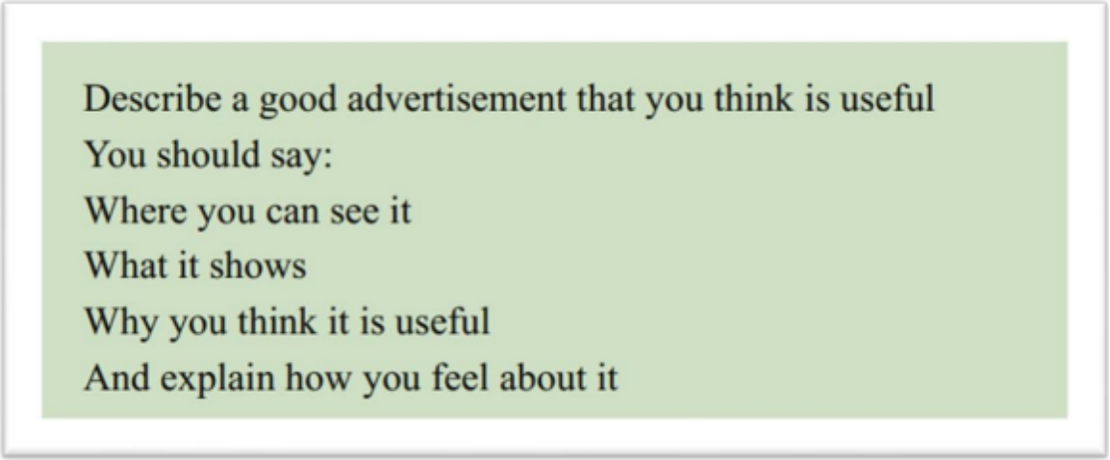

The first advertisement that popped into my mind is the VR technology. VR is short for…virtual reality, maybe? I am really interested in this area. This advertisement mainly exists on the Internet, youtube or bilibili and so on.

I first saw one of the advertisements of VR technology is a VR glasses. In this ad, With a pair of VR glasses, people can go anywhere they like. For example, I have always been very attached to loads of famous tourist attractions such as the pyramids of Egypt and the Great wall of China. I was not able to be there because of my heavy study and workload. But with a pair of vr glasses I can see these landscapes without leaving outside. It is just so peaceful and quiet, or you may say, it is tranquil.

Besides the glasses, do you know that in the mobile app market in China, there are many ads promoting VR applications. For example, they use VR technology to allow clients to see the interior of the house they want to rent or buy without leaving their homes. With this technology, it is easy for me to feel the house type, as if I were there. Everything can be so natural, so real, and so tangible. It can make our lives more efficient and convenient.

And more amazingly, the VR technology helps us to escape from the reality we hate. I mean, people living in the city are always so busy. They are always buzzing around, never willing to spare a second to say hi. You can feel the distance between people. But with VR technology, we can escape from the city and fly all the way to the place we like. It makes me feel relaxed, so I am interested in these ads and want to purchase VR products.

**Part 3:**

1. What do you think of online advertising?

2. Are there any great online advertisements?

3. What do people usually buy?

4. Why does buying new things make people happy?

5. Do people watch useless advertising in this day and age?

6. Do you think there is too much advertising in our daily lives?

**20想法有趣的人**

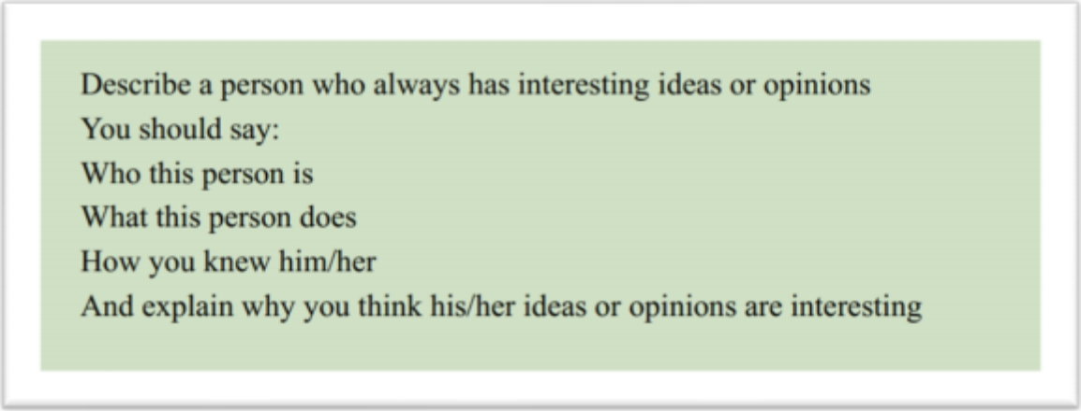

His name is S, which can be loosely translated as Mr. S. He is American, and also an influencer on Youtube. He creates interesting videos about his studying methods and experience.

Actually, I found out about him by accident. My friend was browsing videos on Youtube the other day, and shared his videos with me. The video, I still remember, was about how to improve your spoken Chinese by communicating with strangers. It was so interesting, so intriguing, and it captivated me at once, and I started following him since then.

Basically, he shares videos about his Chinese studying experiences, studying methods, and even life lessons, sometimes. From his video, you can totally tell that he is so smart, it’s like everything in language studying is just a piece of cake to him, he is almost, how to put it, omniscient, I guess. The most interesting video was about him going to any random coffee shop, finding a Chinese person and communicating with him in Chinese. I mean, come on, that’s more than difficult, it’s very difficult, it’s a daunting task. But, he did it! He shared how he chooses a coffee shop and buys a cup of coffee. Then, he carries the cup of coffee to look for someone who speaks Chinese. He asked in the crowd: I'll give you a cup of coffee, can you speak Chinese with me for 10 minutes? Finally, he found a Chinese girl and talked to her for half an hour. I was surprised to see this, no, I was more than surprised, I was stunned.

This is him, a interesting person in the Chinese -studying field. I guess I followed him not only because he is a foreigner who can speak Chinese well, but also because he is so funny, and deep deep down, he resonates with me, I want to improve my spoken English by communicating with strangers.

**Part 3:**

1. When do you think children start to have their own opinions?

2. Are children’s opinion influenced by their parents?

3. Who are smart children likely to be influenced by?

4. How do inventors or philosophers come up with new ideas?

5. Are there only old ideas from books or previous writers?

6. What kind of people have lots of great ideas in your country?

**21美丽的城市**

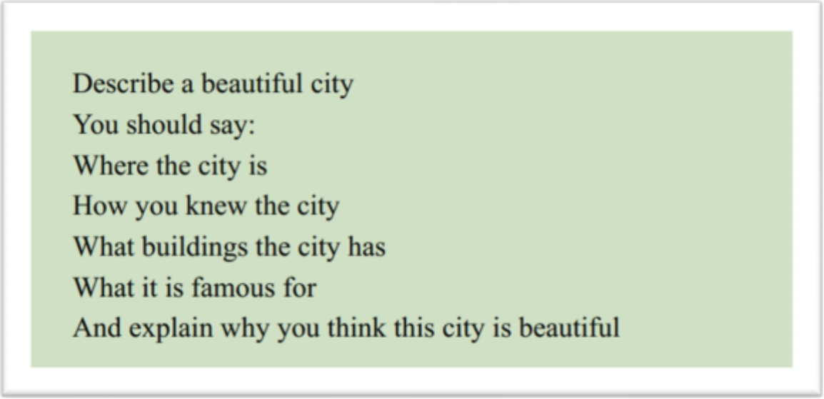

Well, the first beautiful city that popped into my mind is Chengdu. My grandparents live there and I went there last summer. It is just so peaceful and quiet, or you may say, it is tranquil. It slows everything down, and blocks out all the hustle and bustle of the city.

I go to Chengdu every summer. It is easier for me to feel the beauty of nature when I am there. You can always find peace there. It’s not a cliché, I really feel so. I do. In the countryside, you don’t need someone else to tell you spring is here. Instead, you get to see the little buds and the sprouting flowers. I mean, you can see the change of seasons, and it’s with your own eyes. Everything can be so natural, so real, and so tangible.

Last summer, when I was in Chengdu, I found something even more meaningful and gorgeous: the bonds between people. I mean, people living in other big citys are always so busy. They are always buzzing around, never willing to spare a second to say hi. You can feel the distance between people. We are separated by endless traffic jams, by all the tall, fancy but boring buildings. But when I was in Chengdu, things were totally different. The community there is small but close-knit. People know each other, care about each other, and sympathize with each other. It’s good to know there is always a place for you.

**Part 3:**

1. What are the differences between modern towns and modern cities?

2. Why do some people like to visit historical sites?

3. How can people preserve historic cities and historic buildings?

4. Is it the government’s responsibility to preserve historic cities and historic buildings?

5. Does historic preservation contradict economic development?

6. What do you think will happen to historic places or buildings in the future? Why?

**22感兴趣的地方**

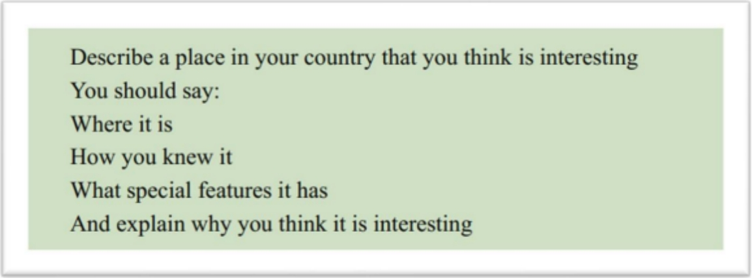

Well, I have always been very interested in the countryside. My grandparents live there and I went there last summer. It is just so peaceful and quiet, or you may say, it is tranquil. It slows everything down, and blocks out all the hustle and bustle of the city. In the countryside, I feel everything is interesting, not so boring as in the city.

I go to the countryside every summer. It is easier for me to feel the beauty of nature when I am there. You can always find peace there. It’s not a cliché, I really feel so. I do. In the countryside, you don’t need someone else to tell you spring is here. Instead, you get to see the little buds and the sprouting flowers. I mean, you can see the change of seasons, and it’s with your own eyes. Everything can be so natural, so real, and so tangible.

Last summer, when I was in the countryside, I found something even more meaningful and interesting: the bonds between people. I mean, people living in the city are always so busy. They are always buzzing around, never willing to spare a second to say hi. You can feel the distance between people. We are separated by endless traffic jams, by all the tall, fancy but boring buildings. But when I was in the countryside, things were totally different. The community there is small but close-knit. People know each other, care about each other, and sympathize with each other. It’s good to know there is always a place for you.

**Part 3:**

1. How can people access travel information?

2. Do people have different personalities in different regions of your country?

3. What causes the differences between different regions of your country?

4. Is it just youngsters who like to try new things, or do people of your parents’ age also like to try new things?

5. Is a great tourist destination also a good place to live?

6. Why do people who go to live in small towns think these towns are more interesting than the big cities?

**23成功的同学**

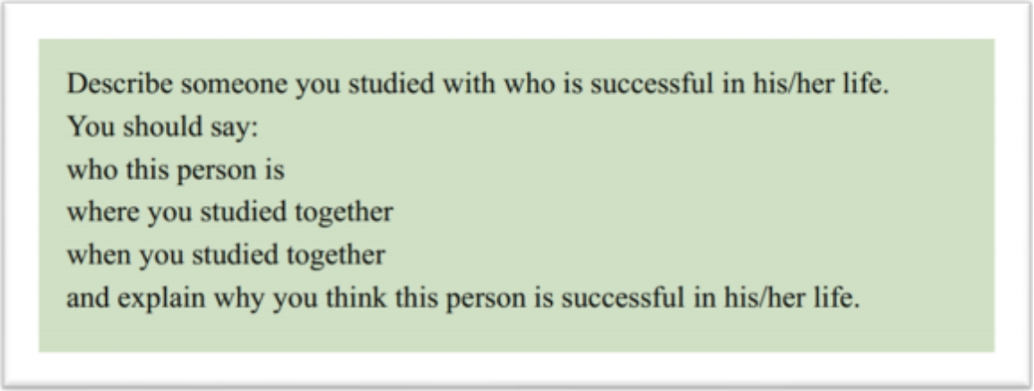

His name is S, which can be loosely translated as Mr. S. He is an influencer on B. He creates videos about his studying methods and experience. He is very successful because he already has over 100,000 followers.

Actually, I found out about him by accident. My friend was browsing videos on B the other day, and shared his videos with me. And I was very shocked, because the person in this video is my primary school classmate, we have spent 6 years of primary school learning time together in Yinchuan, Ningxia, a northwest city of China.

Basically, he shares videos about his studying experiences, studying methods, and even life lessons, sometimes. From his video, you can totally tell that he is so smart, it’s like everything in studying is just a piece of cake to him, he is almost, how to put it, omniscient, I guess. I can’t believe how well he speaks English already. I also can’t believe he has managed to make a lot of money by posting videos. The most impressive and video was how he managed to remember 1000 words in three days. This video has won 80,000 likes. I mean, come on, that’s more than difficult, it’s very difficult, it’s a daunting task. But, he did it! He shared how he divided these words into different groups, and how he adopted various ways to memorize them, and even how he took advantage of different locations to consolidate the memories. I was surprised to see this, no, I was more than surprised, I was stunned.

This is him, a successful person I used to study with. I think he is successful not only because he can teach people how to study English, but also because he can make money out of the videos.

Part 3:

1. Is money the only measure of success in your country?

2. How do you define whether one is a successful person?

3. What is the standard of success in your country?

4. Is there a controversy between success and happiness?

5. Is it easy to succeed in the national tests in your country?

6. What are the factors that influence students' grades at school?

**24感兴趣的历史时期**

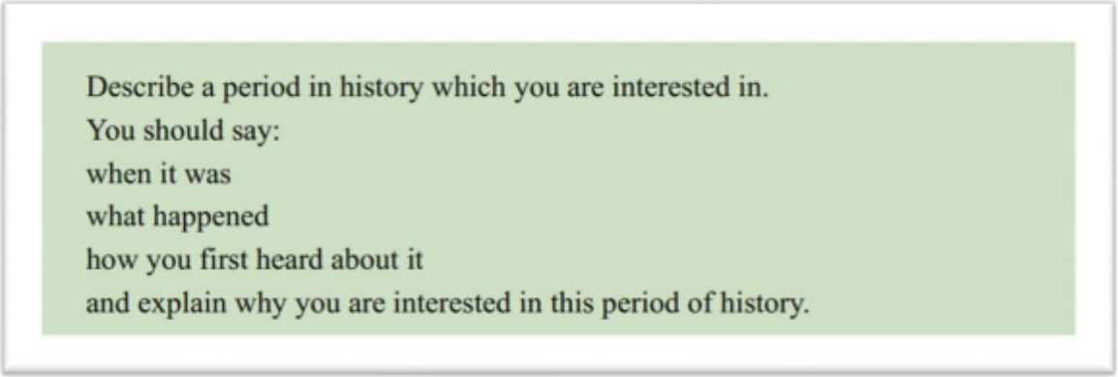

The first period in history that popped into my mind was Tang dynasty. I don’t know much about Chinese history, but I do interested in Tang dynasty, that dates back to more than 1000 years before.

I first heard about it when I was in junior high school. My history teacher told me a story about a Tang Dynasty Princess called Wencheng journey to Tibet. I falled in love with this period immediately. My teacher told me the interpersonal relationship of that period was said to be the best throughout history. There was something really meaningful: the bonds between people. I mean, people nowadays are always so busy. They are always buzzing around, never willing to spare a second to say hi. You can feel the distance between people. But in that period, things were totally different. The community there was small but close-knit. Farmers, fishermen, all the people knew each other, cared about each other, and sympathized with each other.

My teacher also told me After seeing this beauty of Tibet, Princess Wencheng also fell in love with the place and stayed to help the local people. It’s said to be the most beautiful period and all the people cared about the natural environment. Back then, you don’t need someone else to tell you spring is here. Instead, you get to see the little buds and the sprouting flowers. I mean, you can see the change of seasons, and it’s with your own eyes. Everything can be so natural, so real, and so tangible.

**Part 3**

1.Are there any interesting historical places worth visiting in your country?

2. What are the reasons why people are interested in watching historical films?

3. Do children spend too much time studying history?

4. What is the value of museums as a way to study history?

5. Why is it important for people to remember personal events from the past?

6. Why do some people think it's wrong to let the past influence their decisions?

**25刺激的活动**

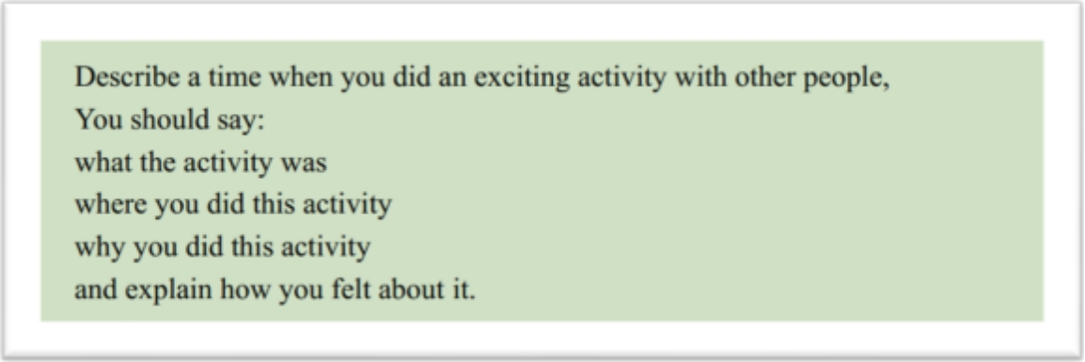

Well, the first activity that popped into my mind is boating. My friends and I went boating in a small river in the countryside just near our city.

Actually, I decide to take part in this activity by accident. My friend was browsing videos on bilibili the other day and shared this video with me. The video, I still remember, was about how to complete a one day boating in the river of countryside. It was so interesting, so intriguing, and it captivated me at once, and I started searching for the information about this spot and decided to go boating with my friends. At this moment, I don’t realise the seriousness of the problem, I mean, how tiring it is.

Basically, this activity is about boating in the river of countryside, enjoying the landscape, and making friends. It’s so exciting! Think about it! I need to control the direction of paddle, use the strength of my arms properly in order to keep the boat steady so that we did not fall into water, and work well with my teammates to keep our movements consistent and more efficient. Actually, I need to have continuous practice right? After a long day of boating, everyone was exhausted but we all thought this was the most exciting activity we had ever done.

**Part 3**

1. What kinds of exciting activities that young people like to do in your country?
2. Why do people choose to do exciting activities, such as extreme sports?
3. How do people benefit from trying new things?
4. Why are some people reluctant to try new things?
5. Are people less willing to try new things as they get older?
6. Should people engage in dangerous stimulating activities?